Batch: C2-1 Roll No.: 16010122104

Experiment / assignment / tutorial No. 4

Grade: AA / AB / BB / BC / CC / CD /DD

Signature of the Staff In-charge with date

TITLE: Program to print patterns

Expected OUTCOME of Experiment:
AIM: Program to print patterns for ‘n’ rows using nested loop ______________________________________________________________________

To successfully run different programs of various patterns.

_____________________________________________________________________
Books/ Journals/ Websites referred:

- Programming in C, second edition, Pradeep Dey and Manas Ghosh, Oxford University Press.
- Programming in ANSI C, fifth edition, E Balagurusamy, Tata McGraw Hill.
- Introduction to programming and problem solving , G. Michael Schneider ,Wiley India edition.
- http://cse.iitkgp.ac.in/~rkumar/pds-vlab/

_____________________________________________________________________

Problem Definition:

The program is to print a pattern as given by the user. The program makes use of a nested loop to print a pattern of characters, numbers or alphabets.

Example:
Input: number of rows = 5, number of columns = 5

Output:
5
4 5
3 4 5
2 3 4 5
1 2 3 4 5

Pattern
#include<stdio.h>
void main ()
{
int i, j;
for(i=0; i<6; i++)
{
for(j=0; j<i+1; j++)
{
printf(" *");
}
printf("\n");
}
getch();
}
Pattern1
#include<stdio.h>
void main ()
{
int i, j;
for(i=1; i<6; i++)
{
for(j=1; j<i+1; j++)
{
printf("%d", i);
}
printf("\n");
}
}

Pattern2
#include<stdio.h>
void main ()
{
int i, j;
for(i=1; i<6; i++)
{
for(j=1; j<i+1; j++)
{
printf("%d", j);
}
printf("\n");
}
}

Pattern3
#include<stdio.h>
void main ()
{
int i, j, k;
for(i=1; i<6; i++)
{
for(k=5; k>i; k--)
{
printf(" ");
}
for(j=1; j<i+1; j++)
{
printf("%d", j);
}
printf("\n");
}
}

Pattern4
#include<stdio.h>
void main ()
{
int i, j;
for(i='A'; i<='E'; i++)
{
for(j='A'; j<i+1; j++)
{
printf("%c", j);
}
printf("\n");
}
}

Pattern5
#include<stdio.h>
void main ()
{
int i, j, k;
for(i=1; i<6; i++)
{
for(k=5; k>i; k--)
{
printf(" ");
}
for(j=i; j>0; j--)
{
printf("%d", j);
}
for(j=2; j<i+1; j++)
{
printf("%d", j);
}
printf("\n");
}
}

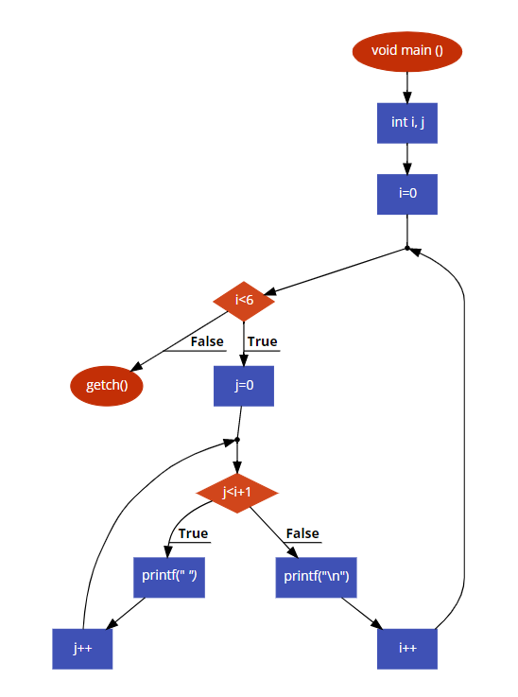
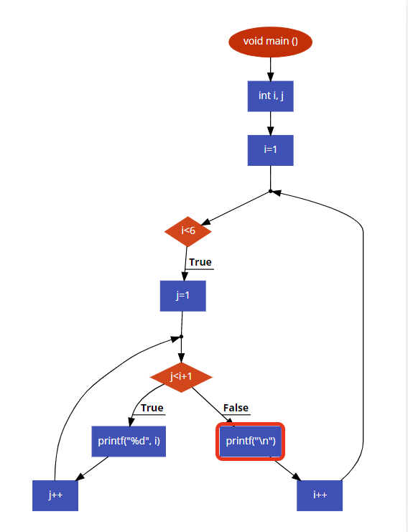
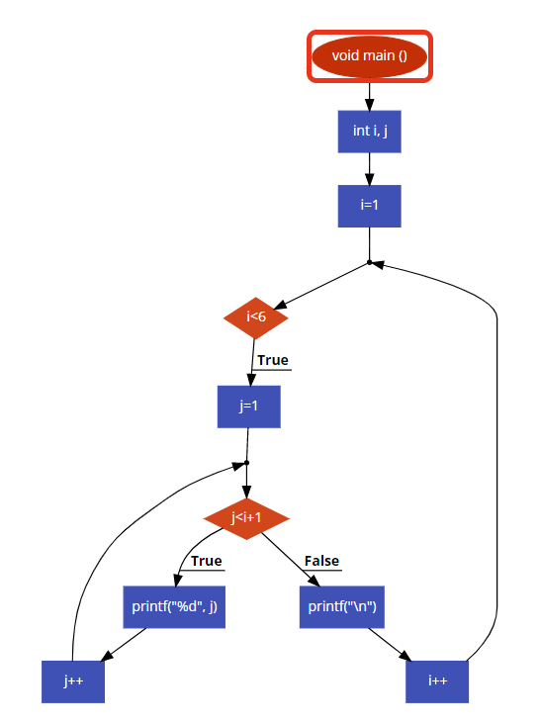
Flowchart:

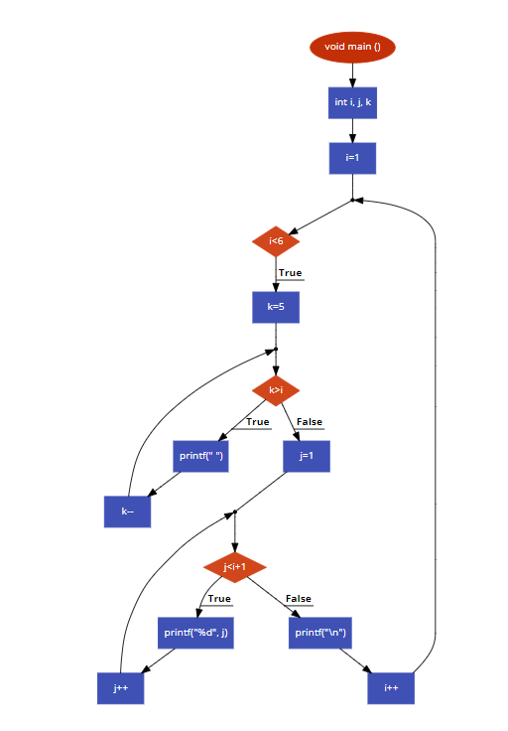
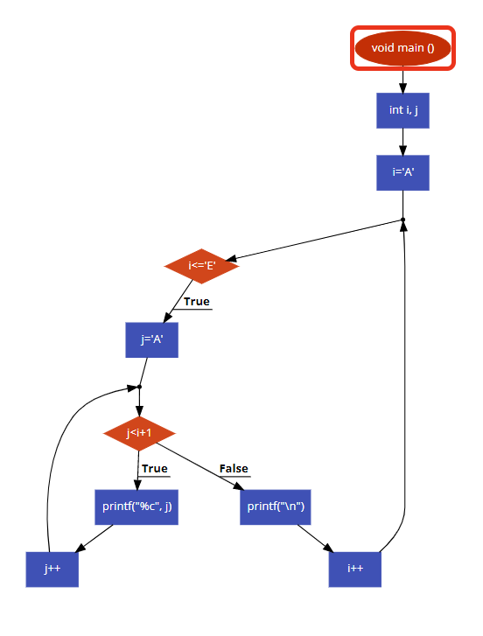
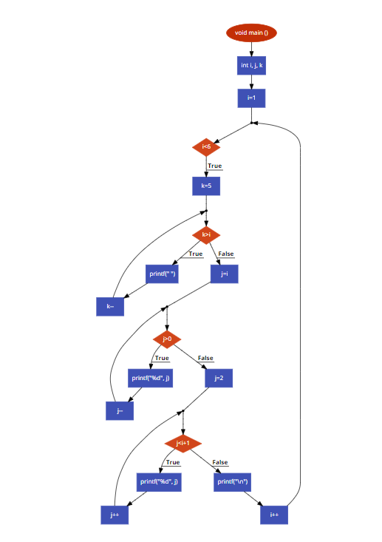

Implementation details:

Pattern:
STEP 1: Start
STEP 2: Declare variables i and j
STEP 3: Create a nested for loop taking i as rows and j as columns
for (initialize i = 1; test condition i<=5 ; post increment i++)
for (initialize j = 1; test condition j<=i ; post increment j++)
print *
print new line
STEP 4: Stop

Pattern1:
STEP 1: Start
STEP 2: Declare variables i and j
STEP 3: Create a nested for loop taking i as rows and j as columns
for (initialize i = 1; test condition i<=5 ; post increment i++)
for (initialize j = 1; test condition j<=i+1 ; post increment j++)
print i
print new line
STEP 4: Stop

Pattern2:
STEP 1: Start
STEP 2: Declare variables i and j
STEP 3: Create a nested for loop taking i as rows and j as columns
for (initialize i = 1; test condition i<=5 ; post increment i++)
for (initialize j = 1; test condition j<=i+1 ; post increment j++)
print j
print new line
STEP 4: Stop

Pattern3:
STEP 1: Start
STEP 2: Declare variables i, j, k
STEP 3: Create a nested for loop taking i as rows and j as columns
for (initialize i = 1; test condition i<=6 ; post increment i++)
for (initialize k = 5; test condition k>i ; post decrement k--)
print space “ ”
for (initialize j = 1; test condition j<=i+1 ; post increment j++)
print j
print new line
STEP 4: Stop

Pattern4:
STEP 1: Start
STEP 2: Declare variables i and j
STEP 3: Create a nested for loop taking i as rows and j as columns
for (initialize i = ‘A’; test condition i<=’E’ ; post increment i++)
for (initialize j = ‘A’; test condition j<=i+1 ; post increment j++)
print j
print new line
STEP 4: Stop

Pattern5:
STEP 1: Start
STEP 2: Declare variables i, j, k
STEP 3: Create a nested for loop taking i as rows and j as columns
for (initialize i = 1; test condition i<=6 ; post increment i++)
for (initialize k = 5; test condition k>i ; post decrement k--)
print space “ ”
for (initialize j = i; test condition j>0 ; post decrement j--)
print j
for (initialize j = 2; test condition j<i+1 ; post increment j++)
print new line
STEP 4: Stop

Output(s):

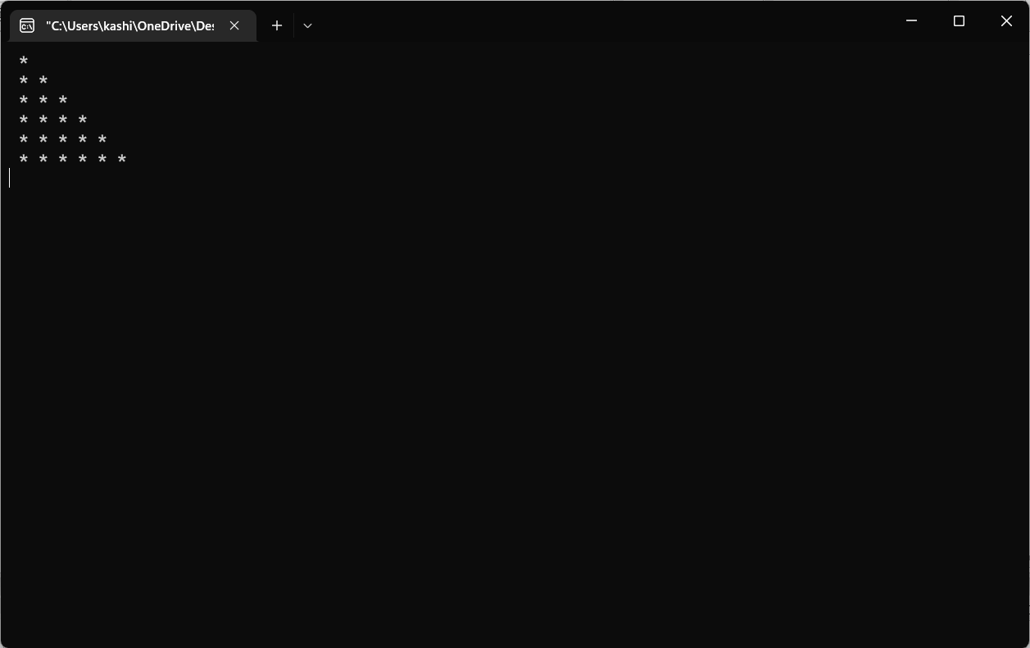
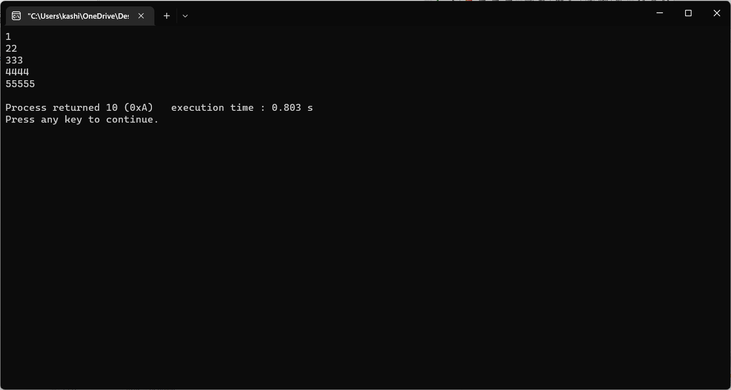
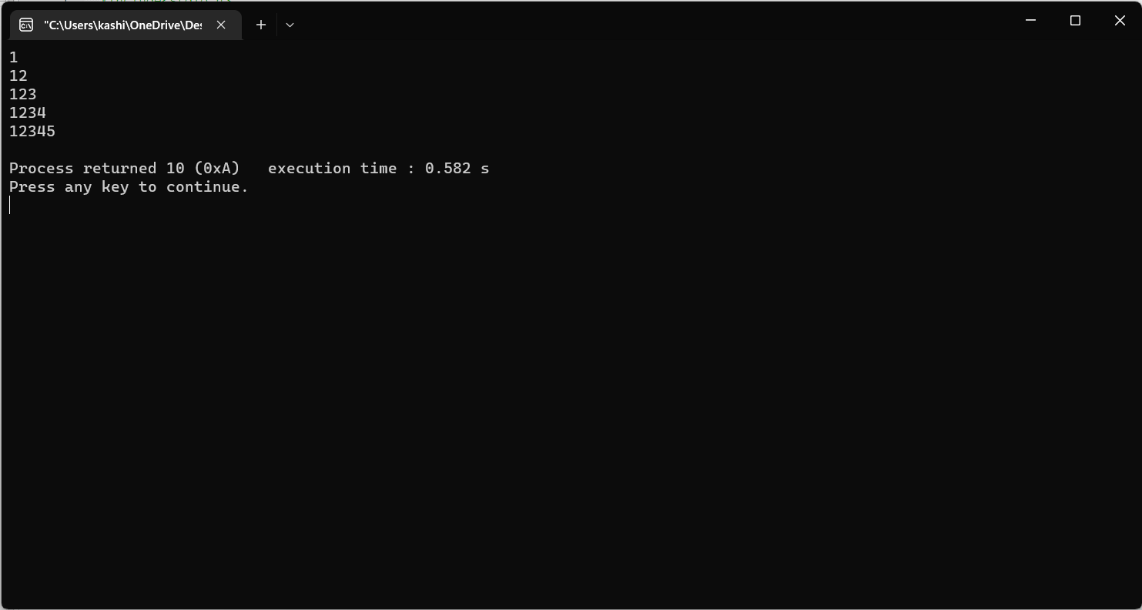
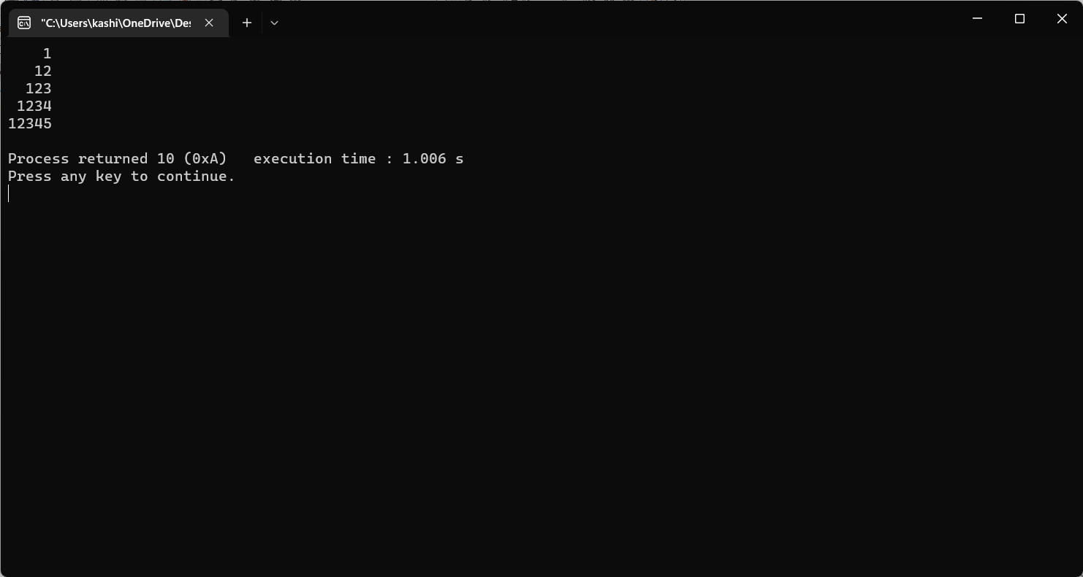
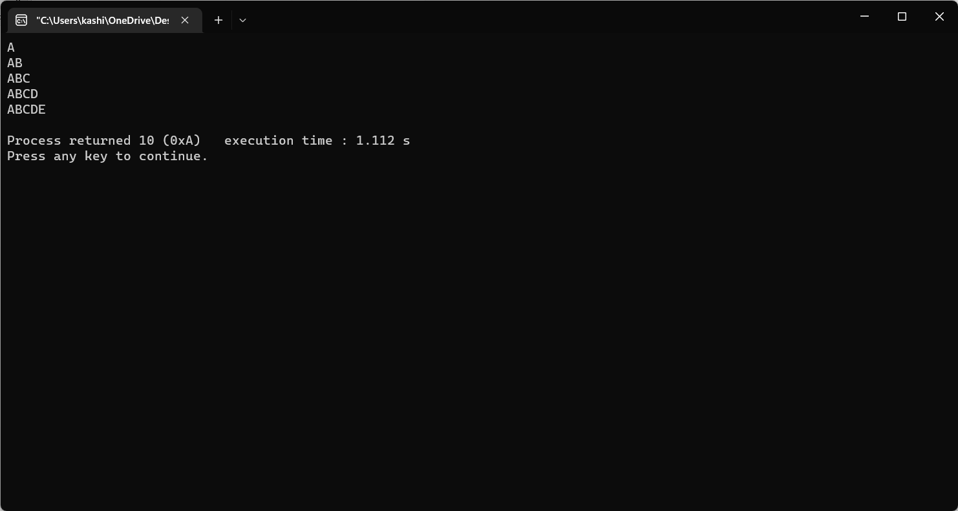
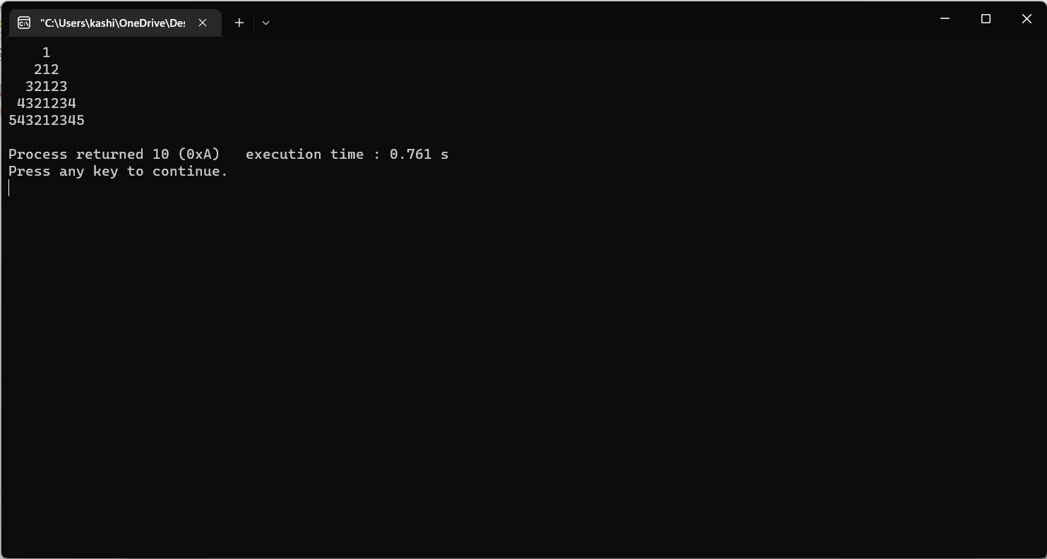

Conclusion:

Various patterns of desired number of rows, columns and sequence can be
printed using the nested for loop.

Post Lab Descriptive Questions

- Write a program to print the following:
1
2 4
3 6 9
4 8 12 16
5 10 15 20 25
6 12 18 24 30 36
7 14 21 28 35 42 49
8 16 24 32 40 48 56 64
9 18 27 36 45 54 63 72 81
10 20 30 40 50 60 70 80 90 100

b) Write a program to print the following pattern:

A
ABA
ABCBA
ABCDCBA

Answers:

a)

#include<stdio.h>
void main()
{
int i,j,k=1;
for(i=1;i<=10;i++)
{
for(j=1;j<=i;j++)
{
printf("%d ",j*i);
k++;

}
printf("\n");
}
}

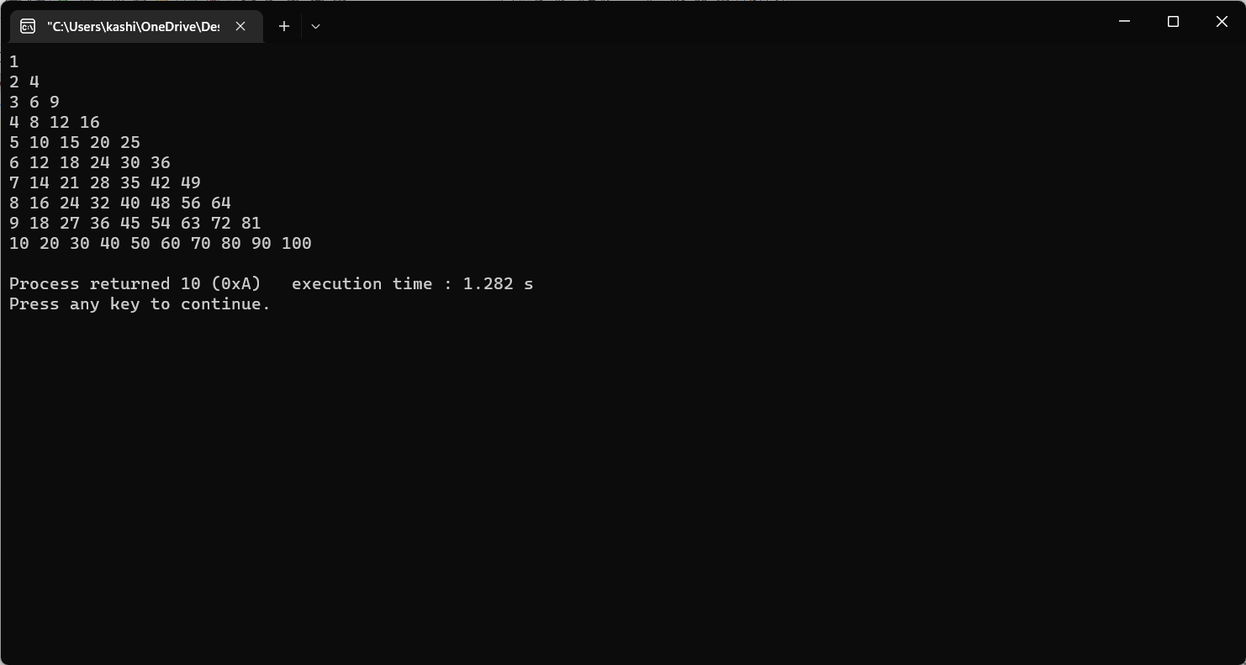

b)

#include<stdio.h>
void main()
{
int i,j;
for(i=1;i<=4;i++)
{
for(j=1;j<=4-i;j++)
{
printf(" ");
}
for(j=1;j<=i;j++)
{
printf("%c",(char)(j+64));
}
for(j=i-1;j>=1;j--)
{
printf("%c",(char)(j+64));
}
printf("\n");

}

}

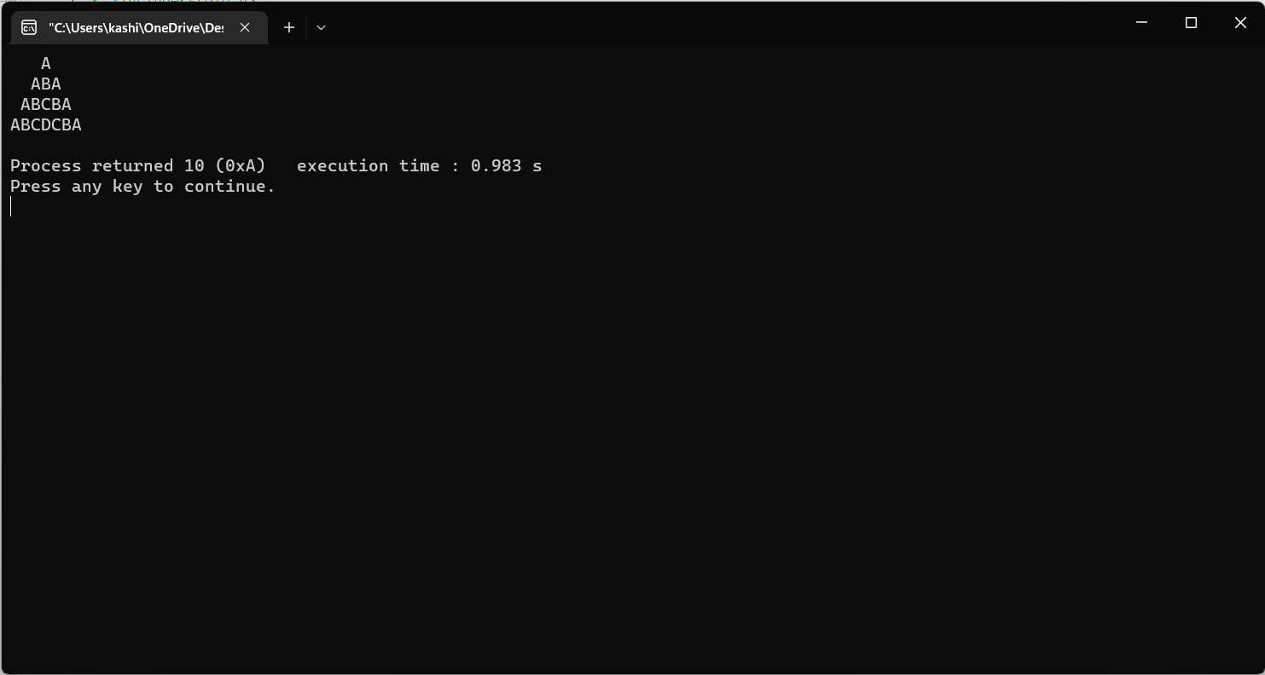

Date: 07/01/2023 Signature of faculty in-charge

